
Where to find the reference information
on a web site.
- What information is needed from a web site to reference it?
- If there is an author for the article you will need the following information:
1
2
3
4
5
- Author/s of the article
- Latest date on which web site was up-dated
- Title of the article
- Web site address
- Date you accessed the web site

Mahler, R.L. & Tindall, T.A., 1997. Soil Sampling [Online]. Available at:
http://209.85.129.132/search?q=cache:Atj423cBnRMJ:info.ag.uidaho.
edu/resources/PDFs/EXT0704.pdf+soil+sampling+methods&cd=
5&hl=en&ct=clnk [Accessed 2 October 2009].
 

- If there is no author for the article, you will need the following information:
1
2
3
4
5
- Title of the article
- Latest date on which web site was up-dated
- Name of the web site
- Web site address
- Date you accessed the web site

Forest biome, 2009 Plantzafrica.com [Online]. Available at:
http://www.plantzafrica.com/vegetation/forest.htm [Accessed 2 October 2009].

- Where do you find the information on the web site?
A: General Advice
- The site is good if it is:
  - Current (must have been updated within the last three years),
  - Authoritative (has author, has contact details, has web control manager, has company details, content is validated, and so forth),
  - Has a reference list attached,
  - Clear about the difference between fact and fiction.
- Refer to the document on the Writing Centre site on R-Drive entitled: Finding sources for an assignment, for further assistance.
- Do not use Wikipedia:
It is not good enough for university standards. Its information is not necessarily scientifically tested, nor is it authoritative. Anyone can access the sites and add information. It is a very poor reflection on your report if Wikipedia is included in your Reference List.
- Work from the HOME page, when necessary
Some of the information can be found on the HOME page – for example: the date of latest update and the name of web site. You can often tell from the HOME page if the site is a good site.
- Try to work from the HTML. document rather than the PDF document.
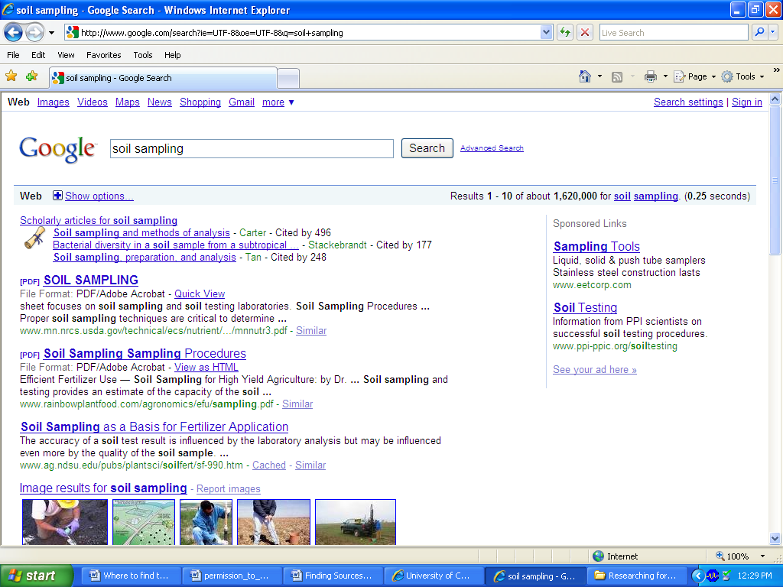
The PDF often does not show enough information to be able to write up the reference. You will need to get to the HOME page on the HTML. web site to find the details. This is done on the Google search page.
PDF document
HTML document

B: Finding the author
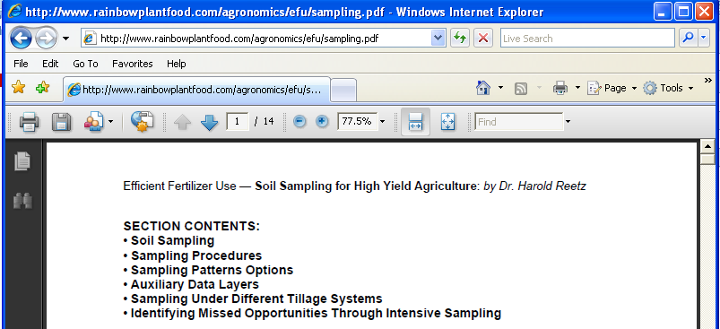
- If the author is given it will either be below the title or at the end of the document.

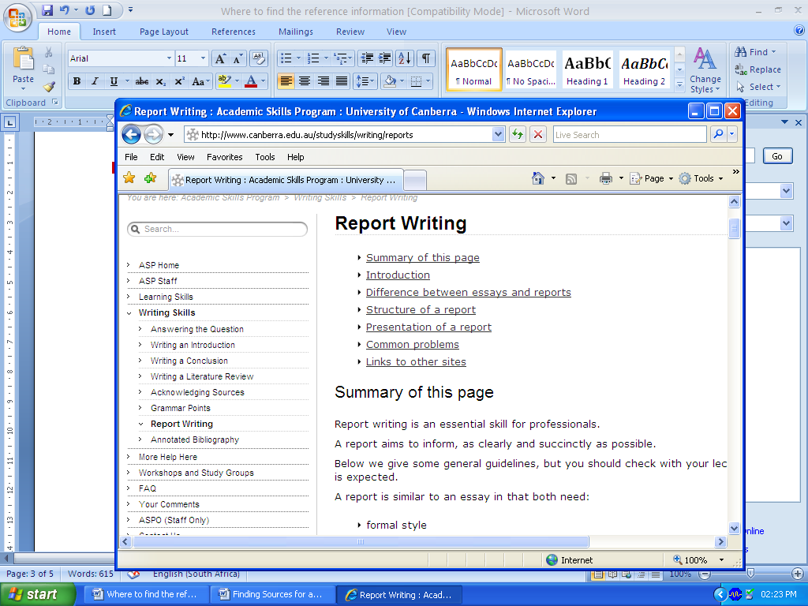
- Some articles on the web do not give the authors as the web designers write the articles. For example: When looking up Report Writing the this site was found. It gives seven sections on Report Writing and none of them has an author. The title Report Writing will be used for the reference.

- An Internet Journal will always have an author. It might have more than one author – you must reference all the authors in full, in your reference list. You may use (et al) in your in-text ref. Refer to the document on referencing advice on the R-drive.

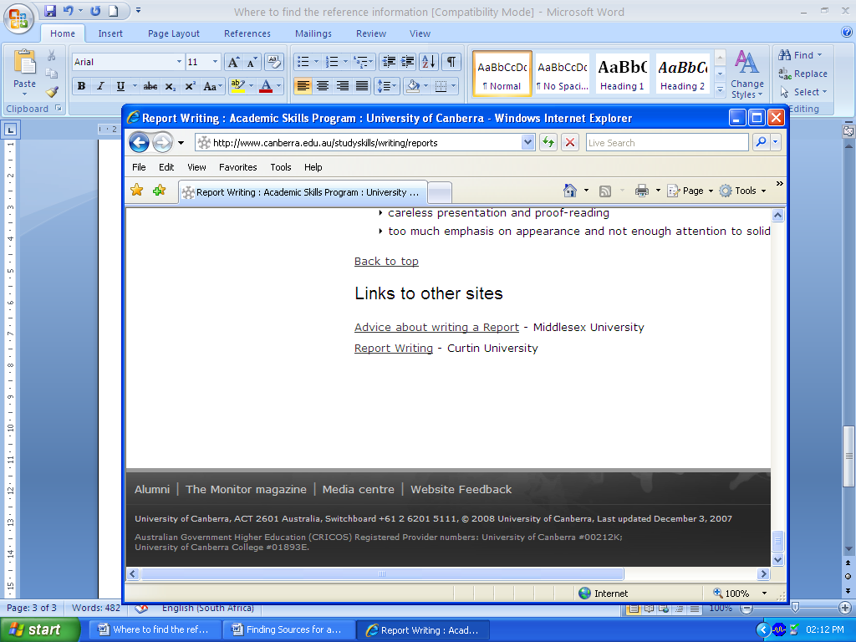
C: Finding the date of the web site

- You need the date at which the latest update was carried out.
- This is often found at the very bottom of the article or the bottom of the HOME page.
- If you cannot find the latest update date, then try to find another date that has been mentioned on the web site (not in the article). The latest one mentioned can also be used, in this case.
- If there is absolutely no date mentioned in the web site, then you can use (n.d.) in your reference list and in your in-text reference. Try to avoid this!
D: Finding the title of the article
- You need the title of the article that has been written – NOT the title of the web site.
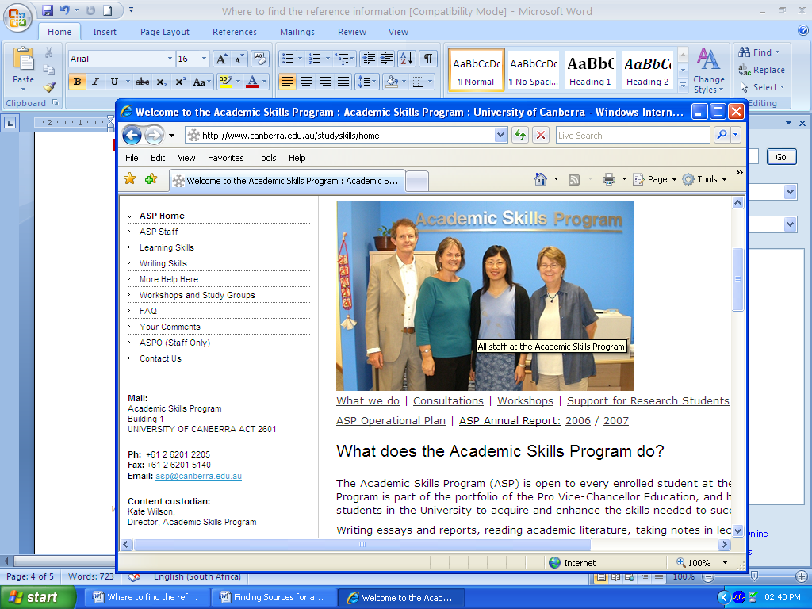
- In this example, the title of the article is: What does the academic skills program do?

E: Finding the web site name
- The name of the web site will be on the HOME page.
- It might also be on the header (top of) the page above your article.
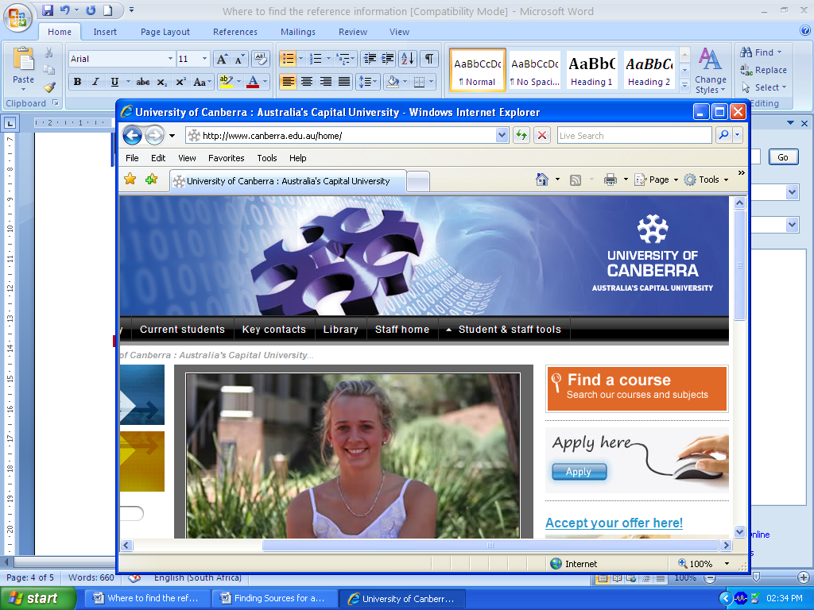
- It might also be part of the web address. For Example: the word Canberra appears in the web address of this web site, however the name of the web site is University of Canberra.

F: Finding the address of the web site
- The web address is the easiest part of the reference to find.
- The address of the article must be given, not that of the HOME page. For example, the web address for the HOME page is given here.

- The web address for the article What does the academic skills program do? is different to that of the HOME page – it has more extensions added on to the end of it.
web address for this article

- It is a good idea to right click, here. Then copy and paste onto your Reference List – this avoids you having to type out the address.
- When do you gather the reference information from the web site?
- It is such a good idea to build up your Reference List as you look for your assignment information.
- Copy and paste the reference information as you access the web site.
- Keep a good record of this – you don’t want to waste time having to go and look up each site again.
- Write the reference in the correct manner before you begin writing your assignment – this makes placing the in-text referencing into the paragraphs so much easier.

